**CAUTION: The bell jar is made of real glass and is fragile**. As it sits in the groove of the Rose base, nothing but gravity and friction holds in place. If the Rose is to be placed on stage where it could get knocked by an errant arm of a student, it is strongly encouraged to use the provided tie-line around the bell jar to anchor the glass to the surface on which it is placed. The tie-line has loops tied into both ends that are meant to be looped over hooks (not supplied) that are well attached to the surface the Rose sits on. The tie-line tends to be invisible from the audience.

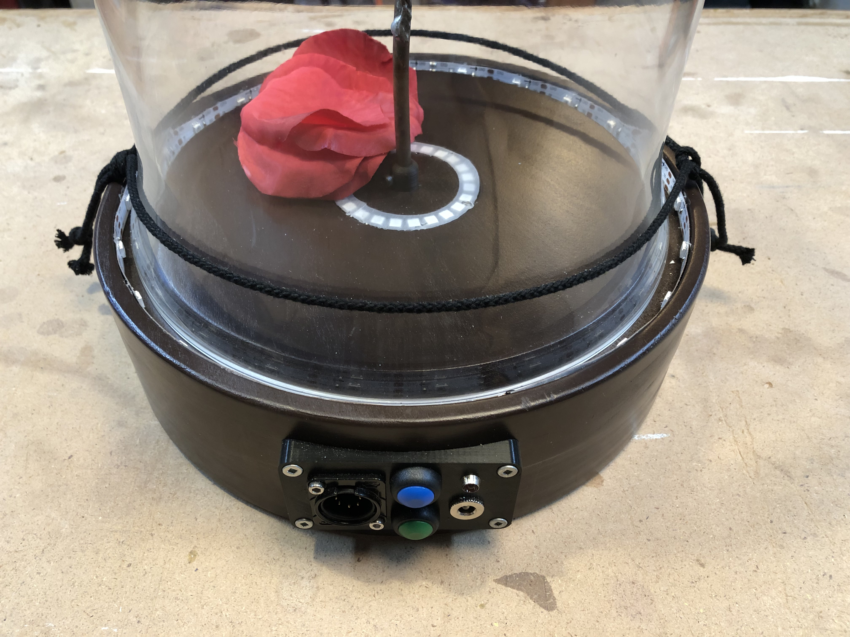

Loop

Loop

**Rear Interface Panel**

The rear interface panel is shown below with the various jacks and buttons labeled.

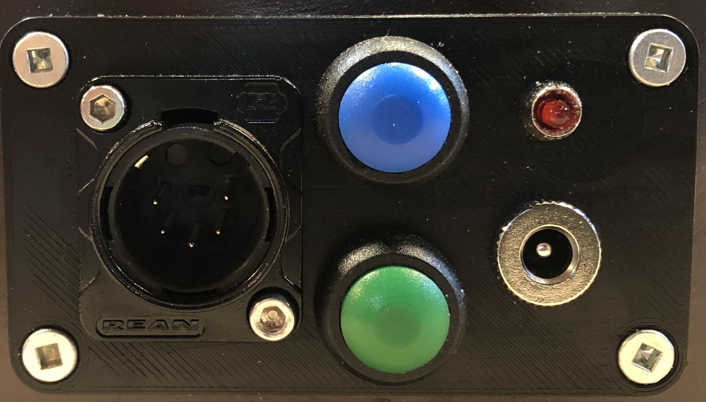

DMX In

Indicator

LED

+12VDC

Input

LED

Override

Petal

Override

* DMX In – 5 Pin XLR Male jack for DMX control
* Indicator LED – LED that flashes with various information.
  + Startup – Flashes quickly 3 times
  + DMX Address – Slowly flashes DMX Base Address after startup (See below)
  + Solid On – Indicates normal functionality
  + Flicker – Indicates DMX bus activity
* +12VDC Input – 5.5 x 2.1mm DC Male Barrel Jack input connector for 12VDC power supply (See below)
* LED Override Button – In the absence of DMX control, LED functions can be sequenced through 1 second button pushes. Same sequence programmed by default. Custom sequences require code changes to microcontroller.
* Petal Override Button – In the absence of DMX control, Petals can be dropped in sequence from 1 to 4 through 1 second button pushes.

DMX In

Indicator

LED

+12VDC

Input

LED

Override

Petal

Override

**Power Interface**

The Rose is powered by a 12VDC, 2A (24W) power supply utilizing a standard 5.5 x 2.1mm DC Male Barrel Jack. In standby while powered on but with no LEDs lit, the Rose draws approximately 2.4W. At full brightness of both LED rings set to white and dropping a petal, the power consumption of the Rose is approximately 11W. Each color channel (R, G, B) draws approximately 2.6W at full brightness.

The Rose can be powered off of a 12VDC battery for wireless operation. At full brightness, the current draw is approximately 916mA at 12VDC. Therefore, if left running in that state for a full show (assuming a worst-case 3-hour run-time) the current consumption is approximately 2750mA hours at 12VDC. In reality, the actual current consumption will be something less than this. A fully charged battery capable of at least 5000mA hours at 12VDC is recommended to start each performance. This does not include the power draw of wireless DMX receivers.

**DMX Interface**

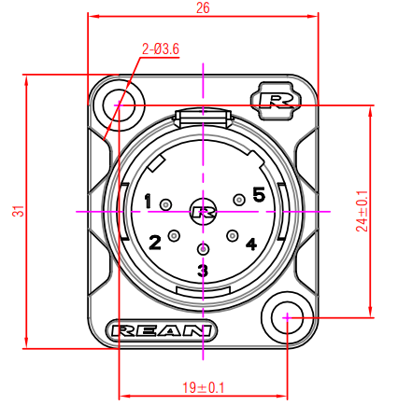The Rose utilizes a standard 5-pin XLR Male connector (Part Number: REAN RC5MDL-B). The wiring conforms to the USITT DMX512-A standard per the table below.

|  |  |  |
| --- | --- | --- |
| **Use** | **5-Pin XLR Pin#** | **Function** |
| Common Reference (GND) | 1 | Data Link Common |
| Primary Data Link | 2 | Data 1- |
| 3 | Data 1+ |
| Secondary Data Link | 4 | Not Connected |
| 5 | Not Connected |

Rose DMX Control utilizes 11 consecutive DMX channels starting with a programmable base address. The DMX Rose Control Mapping table below shows the channel functions.

The Rose has a 120W termination resistor built-in to the DMX Input so as to properly terminate the DMX bus. As the Rose only has a DMX Input, it should be the last device on the chain.

Rose DMX data word values range from 0 to 255 (8-bit). Ensure that your DMX controller for the Rose channels is setup to allow a max value of 255. Frequently, the default max value of a channel is 100 (for example when the channel is used to control “Intensity”)

Each LED ring utilizes 4 DMX channels. The first channel of each ring is a Control value that sets the mode of the ring per the LED Ring Control Codes table below (0-255). The second through fourth channel of each ring set the RGB values (0 to 255) per the same table. The two LED rings can be controlled independently of each other.

The petal drop control utilizes its own DMX channel. The data values to command a petal to drop are listed in the Petal Drop Codes table below. It is recommended to drop the petals in the sequence 1-2-3-4 so as to prevent the petals from getting hung up on each other. Loading the petals back onto the rose head should be done in reverse order, 4-3-2-1.







The base DMX address for the controlling the rose is set via DIP switches located inside the electronics per the DMX Base Address Setting table below. The user is strongly encouraged not to change this. The current base address is counted out after power on by the indicator light on the back of the Rose starting with a quick three flashes to indicate initialization is complete, then the DMX Base Address 100’s digit followed by the 10’s digit and then the 1’s digit.

The default base DMX address is 465.



**Attaching Petals**

The Rose top is marked with the label and position of the four petal attachment points. Directly below the numbers printed on the drop, are magnets that hold the petals in place. Servos located in the base of the Rose, pull the magnets back when cued which releases the appropriate petal. The Rose top and magnets are shown below.

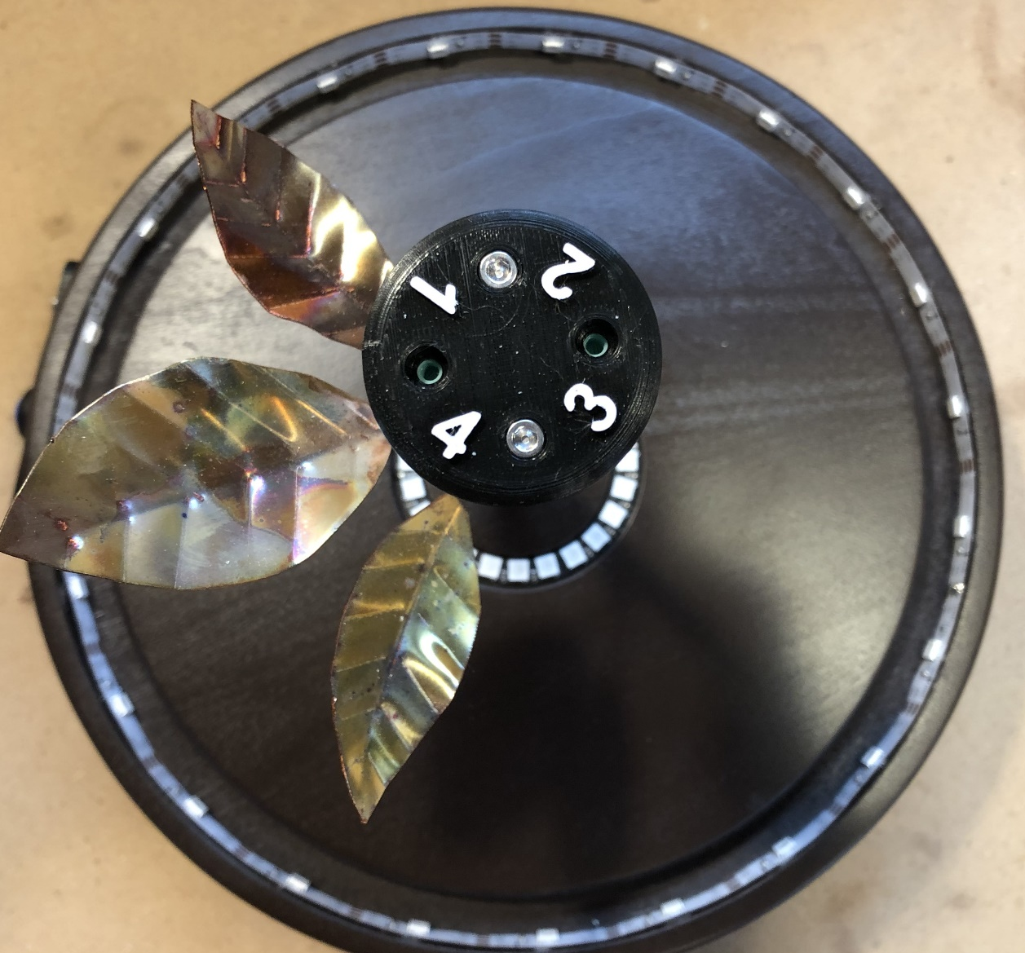

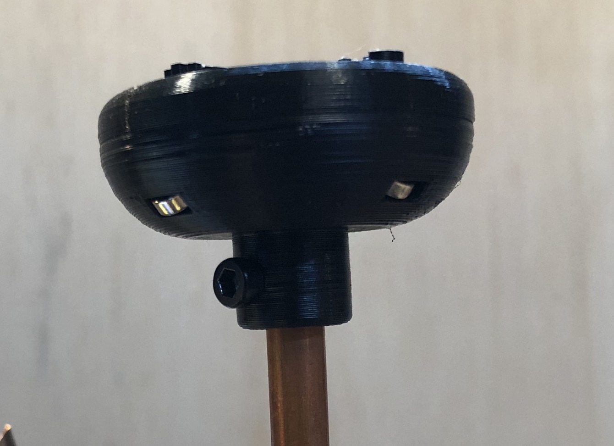

Magnets

Four petals have metal disks attached to their bottoms which are what the magnets hold in place. Three additional petals (filler petals) have no metal and are intended to be “doubled-up” with the other petals to help fill out the appearance of the rose and will drop along with the disk petals. The filler petals are fully optional. The filler petals have a red dot marked on them to indicate which is their bottom.

Typically petals 1, 2 and 3 are doubled-up with petal 4 being a single petal as indicated by the script.

The petals should attached in reverse sequence order (4-3-2-1) and dropped in forward sequence (1-2-3-4) to avoid petals getting hung up on each other as they overlap when installed on the Rose top.

To attach the petals, starting with #4, place a petal with its metal disk over the magnet slot. When held close enough, the magnet will grab the disk and you hear and feel a click. The petal will hold itself in place. Optionally (and recommended) you can place the bottom of filler petal in between the metal disk and the magnet. The magnets are strong enough to hold up both petals. When cued, both petals will drop from the respective magnet.

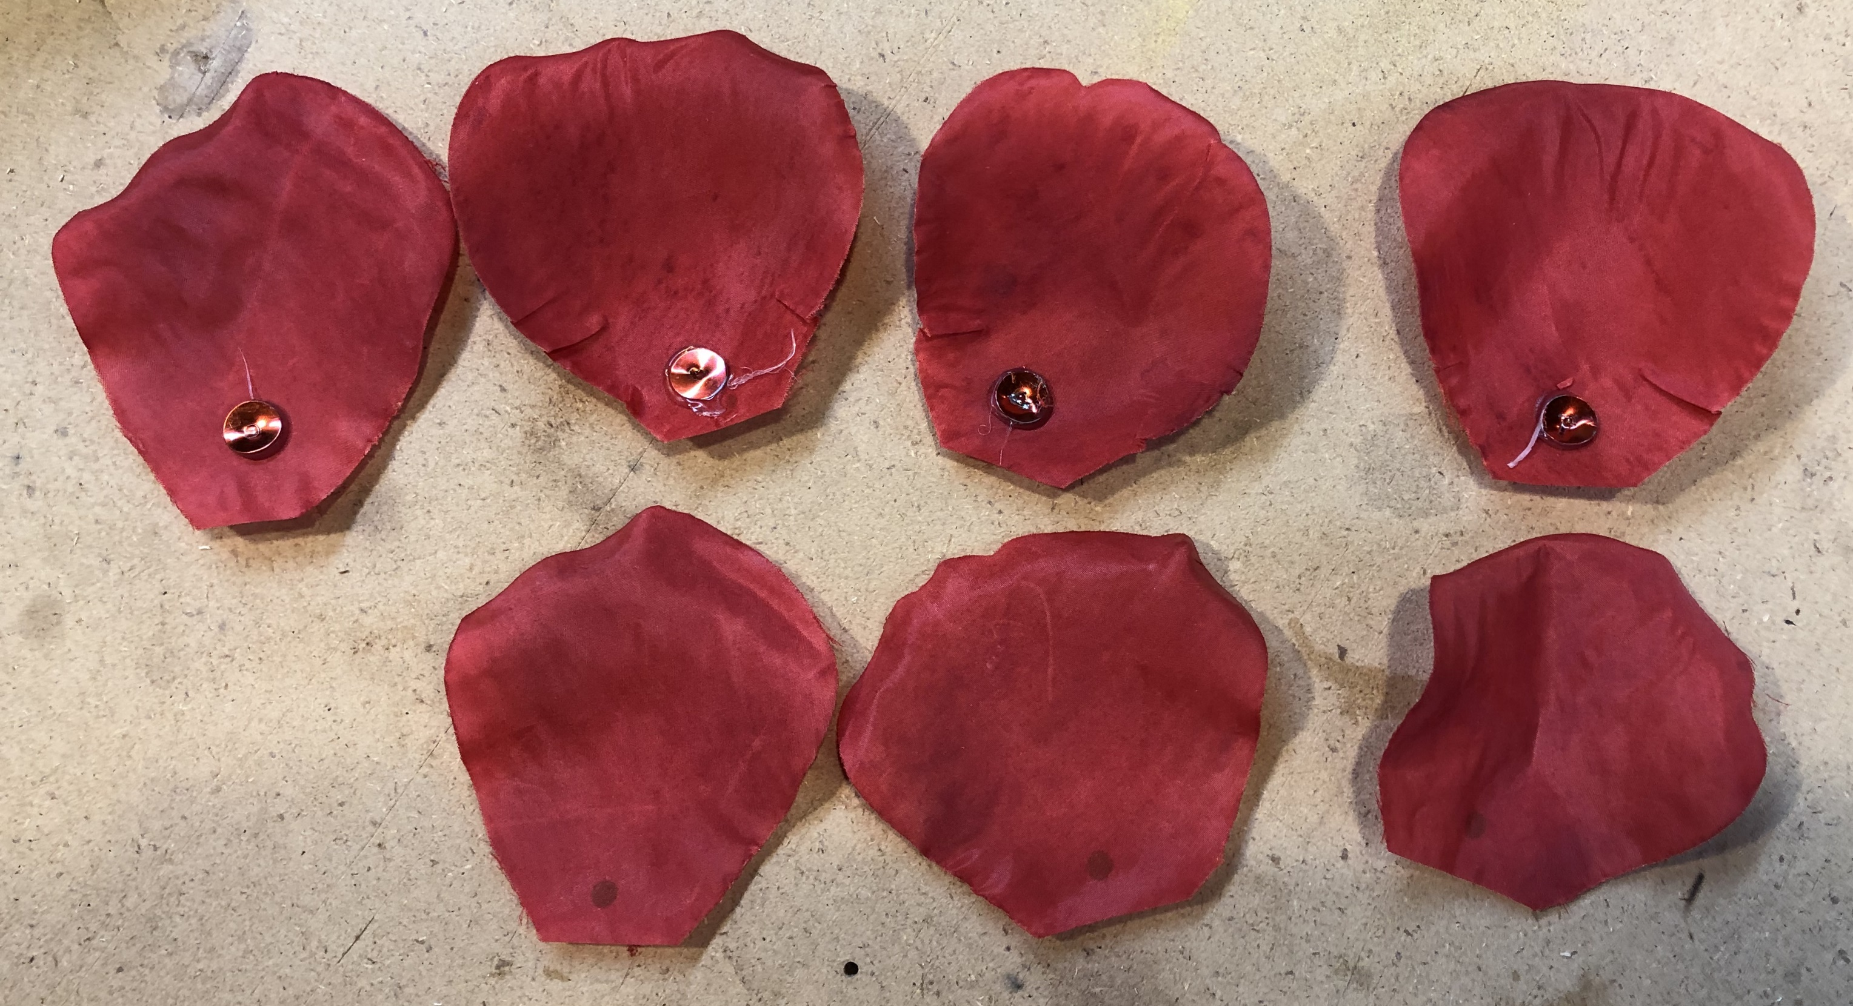

Metal Disk

Filler Petals with Red Dot

Petal #4 attached:

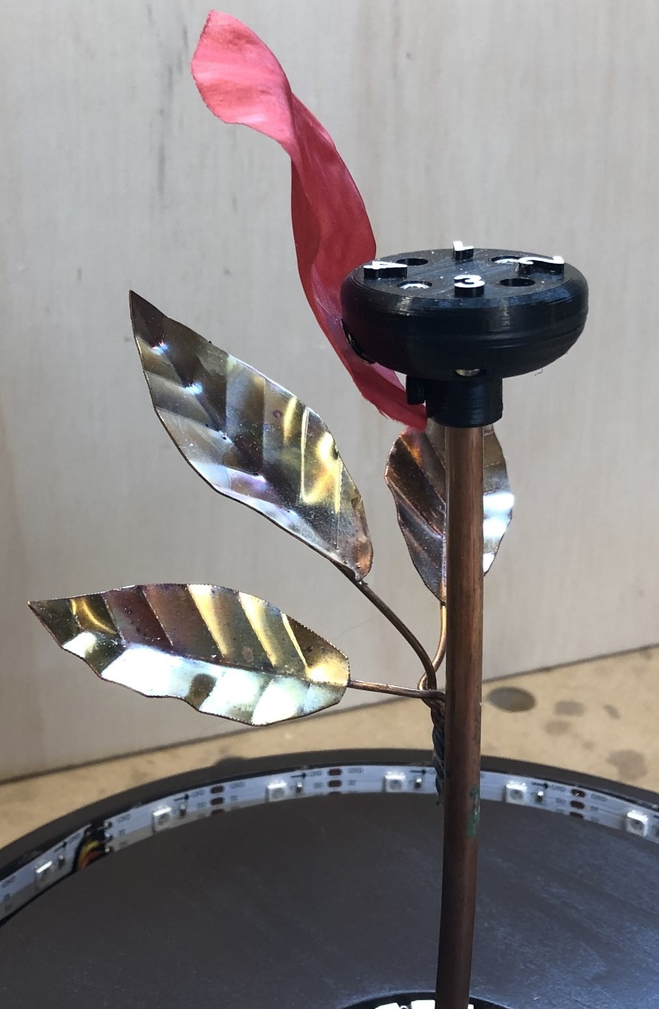

Doubling-up a filler petal:

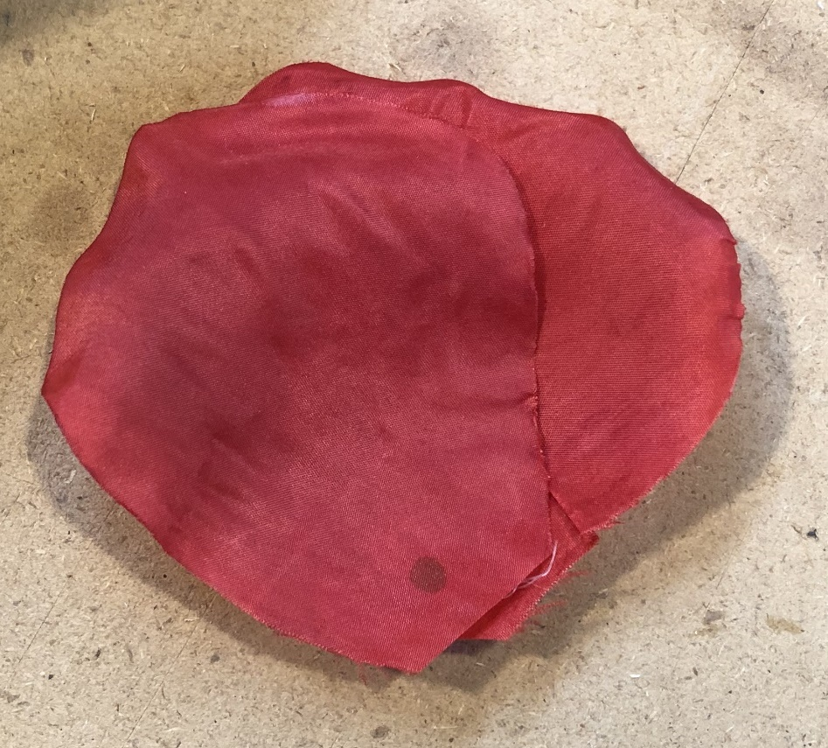

All petals attached:

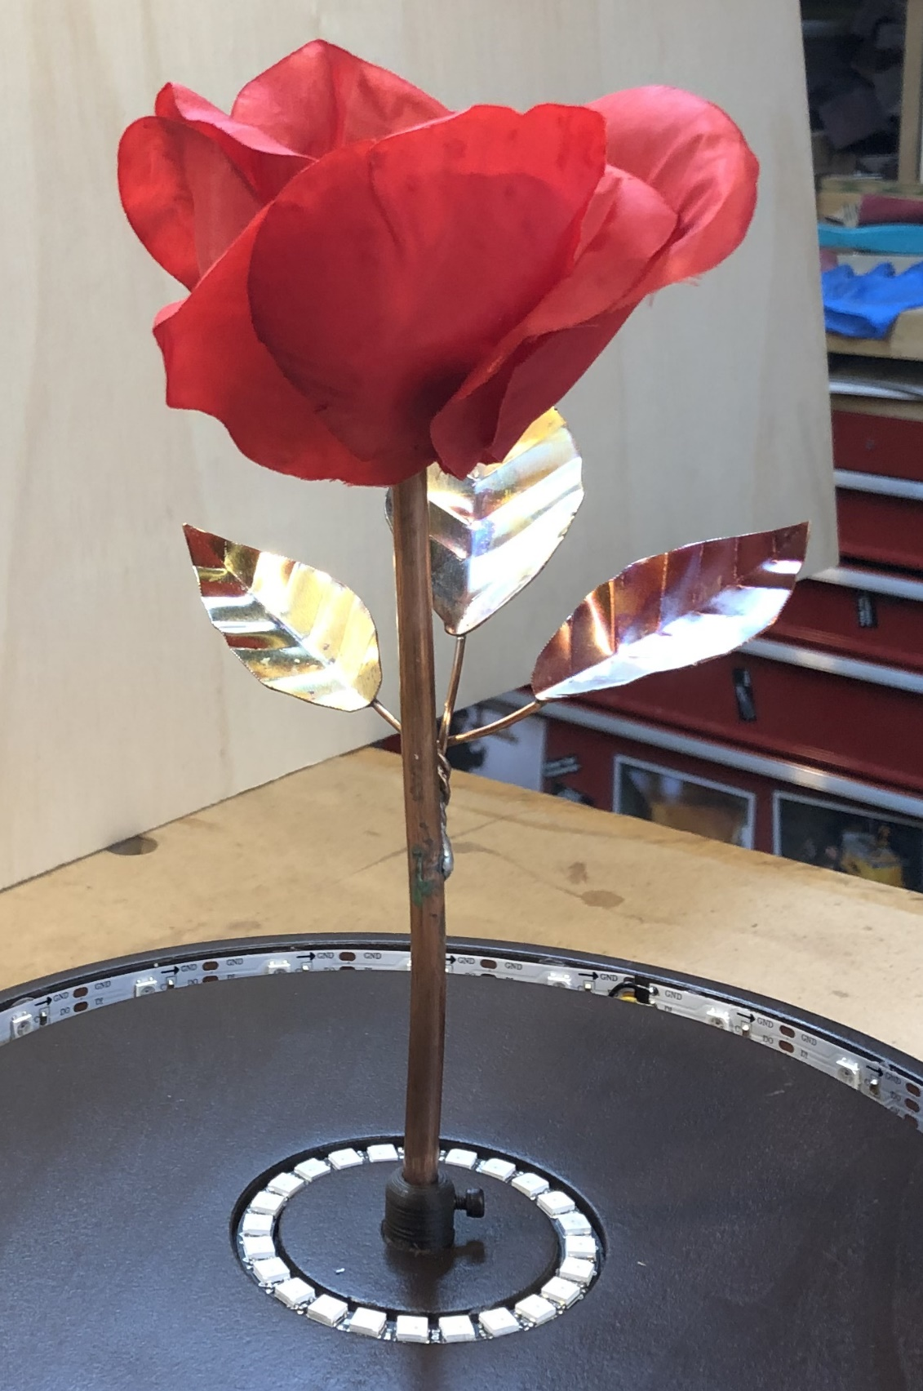

**Rose Cues in Script:**

Below are the cues locations we used for the show. The script is silent on drop 2 and drop 3, so the locations listed here are our interpretation along with input form other directors. Prior to dropping the petal, we used the chasing lights modes of the LED rings to bring attention to the Rose so the audience would notice the petals drop. Pulsing the LEDs would also be a good way of drawing attention.

**Petal #1:** #8b How Long Must This Go On? – Immediately after “How to win the world’s forgiveness”

**Petal #2:** #10 If I Can’t Love Her– Immediately after “I Moved Onward” for orchestra swell

**Petal #3:** #16 If I Can’t Love Her Reprise – On “Free” of “Wait for death to set me free”

**Petal #4:** #19 Transformation/Finale – On (He Dies) cue

**Packing Up the Rose**

**Packing Up the Rose**

**Petal #2:** #10 If I Can’t Love Her– Immediately after “I Moved Onward” for orchestra swell

**Packing Up the Rose**

When placing the Rose back into its box, be sure to place the base in the correct orientation in the foam cutout. The petals should be placed inside the bell jar. The power cord brick should be placed into its cutout in the foam and the cord wrapped around the base counter-clockwise with the cord jack end being inserted into the hole in the foam.

